**Name:** JAYASURYA C  
**Department:** B.Tech Information Technology  
**Course:** Operating Systems  
**Course Code:** CSA0403  
**Experiment No.:** 7

Construct a C program to implement non-preemptive SJF algorithm

### ****AIM****

The aim of this program is to implement **CPU Scheduling using the Shortest Job First (SJF) Non-preemptive algorithm**, where the process with the smallest burst time among the available processes is executed first.

### ****ALGORITHM****

Start the program.

Read the number of processes along with their **Arrival Time (AT)** and **Burst Time (BT)**.

At the current time, select the process that has:

Already arrived (AT ≤ current time).

The **smallest burst time**.

Execute the selected process until completion (non-preemptive).

Record its **Completion Time (CT)**, then calculate:

**Turnaround Time (TAT) = CT – AT**

**Waiting Time (WT) = TAT – BT**

Repeat until all processes are completed.

Display the process details with AT, BT, CT, TAT, and WT.

Compute and display **average WT** and **average TAT**.

End the program

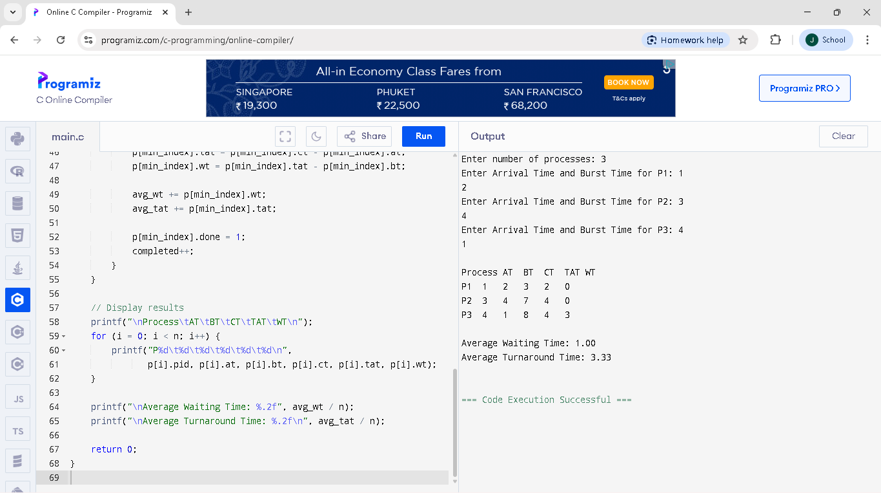PROGRAM/OUTPUT: